Practical 6

Title / Aim :- Use string functions and regex for email validation, data extraction, and text analysis.
Software/Tools Required: VS Code , Web Browser
Experiment program code:
Index.html
<!DOCTYPE html>
<html lang="en">
<head>
<meta charset="UTF-8">
<meta name="viewport" content="width=device-width, initial-scale=1.0">
<title>Resume Text Analyzer</title>
<link rel="stylesheet" href="style.css">
</head>
<body>
<div class="container">

<header>
<div class="icon">📄</div>
<h1>Resume Text Analyzer</h1>
<p>Analyze resume content using JavaScript String Functions & Regex</p>
</header>

<!-- Input -->
<section class="card">

<h2>📝 Paste Your Resume</h2>

<textarea id="resumeText"
placeholder="Paste your resume text here...

Example:
Sanvi Wadhankar
Email: wadhankarsanvi@gmail.com
Phone: 9960695022
Skills: JavaScript, Python, HTML, CSS
Education: B.Tech Computer Science
Experience: Software Development Intern">
</textarea>

<button class="analyze-btn" onclick="analyzeResume()">
🔍 Analyze Resume
</button>

</section>

<!-- String Functions -->
<section class="card">

<h2>🔤 String Analysis</h2>

<div class="grid">

<div class="box">
<h3>Length</h3>
<p id="length">-</p>
</div>

<div class="box">
<h3>Words</h3>
<p id="wordCount">-</p>
</div>

<div class="box">
<h3>Characters</h3>
<p id="characters">-</p>
</div>

<div class="box">
<h3>Uppercase</h3>
<p id="uppercase">-</p>
</div>

<div class="box">
<h3>Lowercase</h3>
<p id="lowercase">-</p>
</div>

<div class="box">
<h3>Trimmed Text</h3>
<p id="trimmed">-</p>
</div>

</div>

</section>

<!-- Email Extraction -->
<section class="card">

<h2>📧 Extracted Email IDs</h2>

<div id="emails" class="email-result">
No email IDs found.
</div>

</section>

<!-- Skill Search -->
<section class="card">

<h2>💻 Check Resume Skill</h2>

<div class="search-box">

<input
type="text"
id="skill"
placeholder="Enter skill e.g. Python"
>

<button onclick="checkSkill()">
Check Skill
</button>

</div>

<p id="skillResult"></p>

</section>
<!-- Replace -->
<section class="card">

<h2>✏️ Replace Text</h2>

<div class="search-box">

<input
type="text"
id="oldText"
placeholder="Text to replace"
>

<input
type="text"
id="newText"
placeholder="New text"
>

<button onclick="replaceText()">
Replace
</button>

</div>

<p id="replaceResult"></p>

</section>

</div>
<script src="script.js"></script>
</body>
</html>

Style.css
* {
box-sizing: border-box;
margin: 0;
padding: 0;
font-family: Arial, sans-serif;
}
body {
background: #91c0f0;
color: #1e293b;
padding: 30px;
}
.container {
max-width: 1000px;
margin: auto;
}
/* Header */
header {
background: #334155;
color: white;
text-align: center;
padding: 35px;
border-radius: 18px;
margin-bottom: 25px;
}
.icon {
font-size: 45px;
}
header h1 {
margin: 10px 0;
font-size: 32px;
}
header p {
color: #cbd5e1;
}
/* Cards */
.card {
background: white;
padding: 25px;
margin-bottom: 20px;
border-radius: 15px;
box-shadow: 0 4px 12px rgba(0, 0, 0, 0.08);
}
.card h2 {
margin-bottom: 20px;
color: #334155;
}
/* Resume Input */
textarea {
width: 100%;
height: 220px;
padding: 15px;
border: 2px solid #cbd5e1;
border-radius: 10px;
resize: vertical;
font-size: 15px;
outline: none;
}
textarea:focus {
border-color: #334155;
}
/* Buttons */
button {
padding: 11px 18px;
border: none;
border-radius: 7px;
background: #334155;
color: white;
cursor: pointer;
font-size: 15px;
}
button:hover {
background: #1e293b;
}
.analyze-btn {
width: 100%;
margin-top: 15px;
padding: 14px;
font-size: 17px;
font-weight: bold;
}
/* Analysis */
.grid {
display: grid;
grid-template-columns: repeat(3, 1fr);
gap: 15px;
}
.box {
background: #f8fafc;
border-left: 4px solid #334155;
padding: 18px;
border-radius: 8px;
}
.box h3 {
font-size: 15px;
margin-bottom: 8px;
}
.box p {
color: #475569;
word-break: break-word;
}
/* Emails */
.email-result {
background: #f8fafc;
padding: 15px;
border-radius: 8px;
}
.email {
display: block;
background: #e2e8f0;
padding: 10px;
margin: 7px 0;
border-radius: 6px;
color: #1e293b;
font-weight: bold;
}
/* Search */
.search-box {
display: flex;
gap: 10px;
}
.search-box input {
flex: 1;
padding: 11px;
border: 1px solid #cbd5e1;
border-radius: 7px;
font-size: 15px;
}
#skillResult,
#replaceResult {
margin-top: 15px;
font-weight: bold;
}
/* Mobile */
@media (max-width: 700px) {

.grid {
grid-template-columns: 1fr 1fr;
}

.search-box {
flex-direction: column;
}
}
@media (max-width: 450px) {

.grid {
grid-template-columns: 1fr;
}
}
Output:-
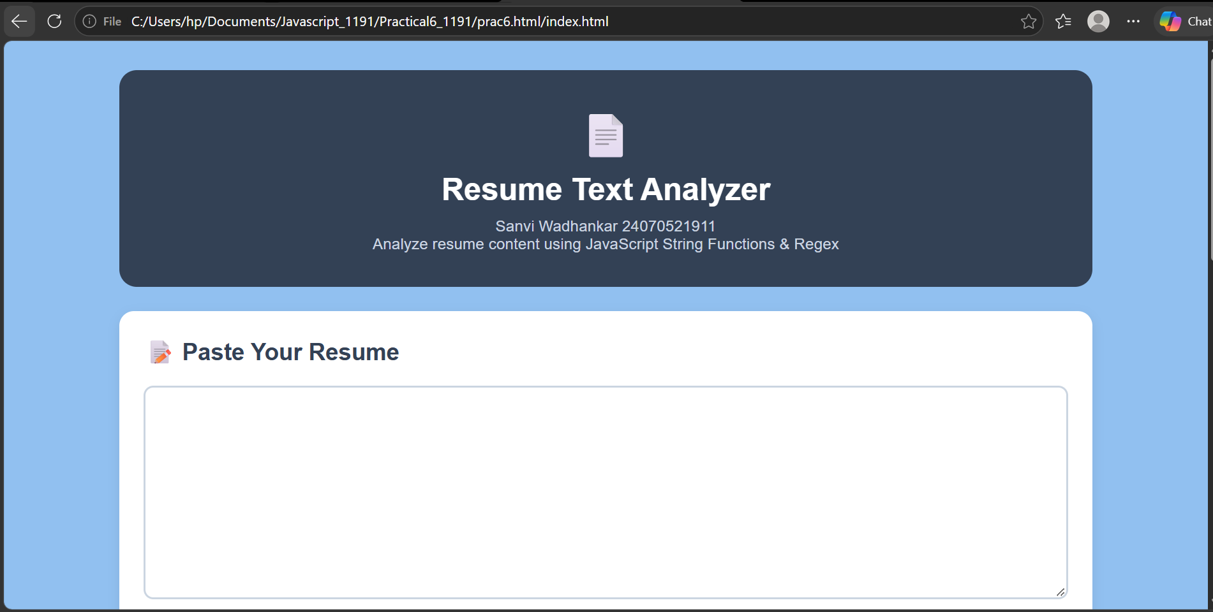
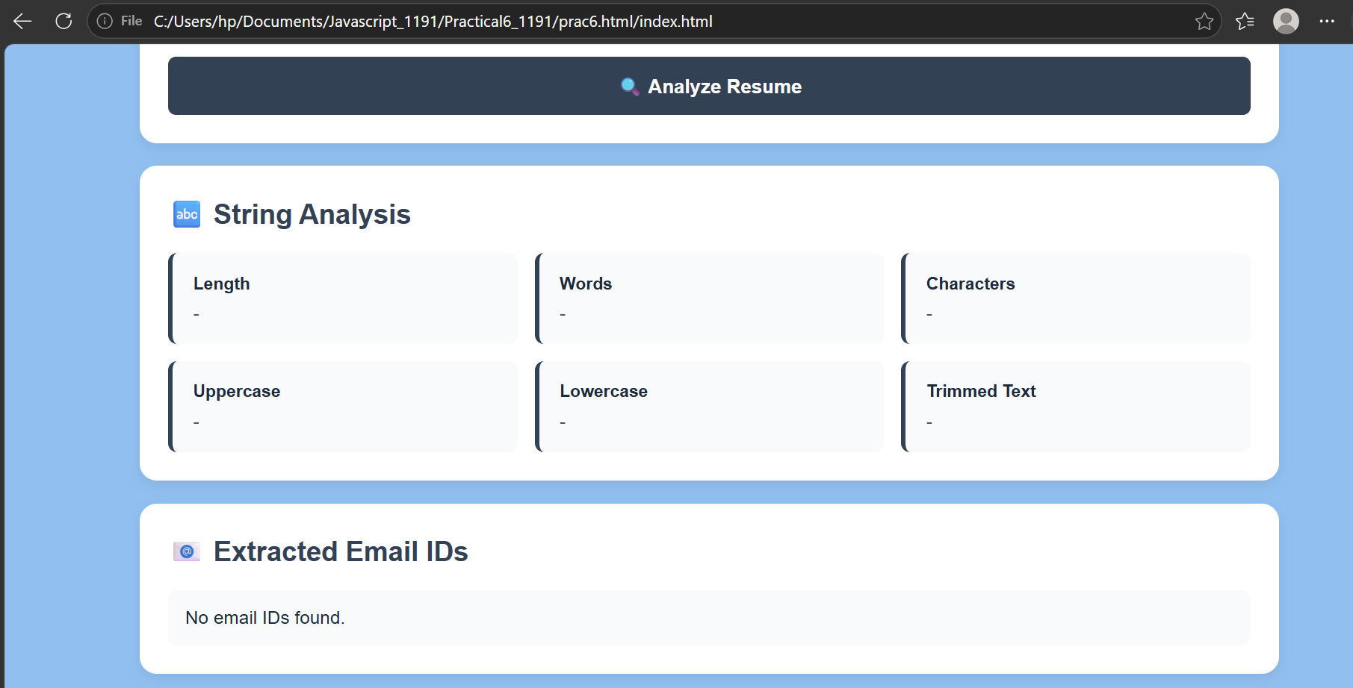
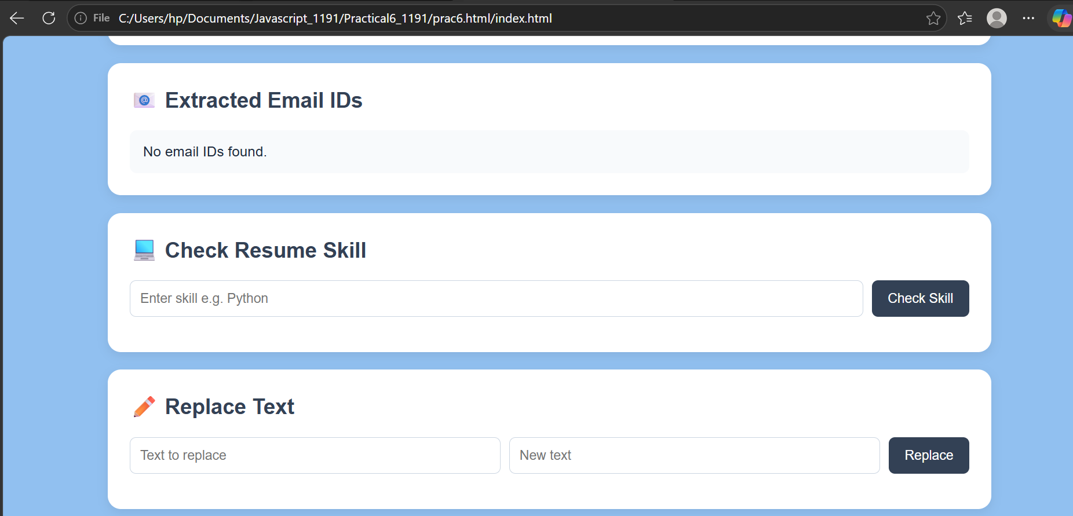
Case Study 6
Aim:- To perform basic string operations ; to reverse a string and count number of vowels in a paragraph
Software/Tools Required: VS Code , Web Browser
Case Study Code:-
<!DOCTYPE html>
<html>
<head>
<title>String Operations in JavaScript</title>

<style>
body {
font-family: Arial, sans-serif;
background-color: #f3f6fb;
text-align: center;
padding: 30px;
}

h2 {
color: #1a5cff;
}

.box {
background-color: white;
max-width: 700px;
margin: 20px auto;
padding: 25px;
border-radius: 10px;
box-shadow: 0 4px 12px rgba(0,0,0,0.1);
text-align: left;
}

input, textarea {
width: 95%;
padding: 10px;
margin: 8px 0 15px;
border: 1px solid #bbb;
border-radius: 6px;
font-size: 15px;
}

textarea {
height: 120px;
resize: vertical;
}

button {
padding: 10px 18px;
background-color: #1a5cff;
color: white;
border: none;
border-radius: 6px;
cursor: pointer;
margin: 5px;
}

button:hover {
background-color: #0d3fb0;
}

.result {
background-color: #f8fafc;
padding: 12px;
margin-top: 15px;
border-left: 4px solid #1a5cff;
line-height: 1.7;
}
</style>
</head>

<body>

<h2>String Operations using JavaScript</h2>
<h3>Sanvi Wadhankar 24070521191</h3>

<!-- =========================
BASIC STRING OPERATIONS
========================== -->

<div class="box">

<h3>1. Basic String Operations</h3>

<input
type="text"
id="stringInput"
placeholder="Enter a string"
>

<button onclick="basicOperations()">
Perform Operations
</button>

<div id="basicResult" class="result"></div>

</div>

<!-- =========================
REVERSE STRING
========================== -->

<div class="box">

<h3>2. Reverse a String</h3>

<input
type="text"
id="reverseInput"
placeholder="Enter a string"
>

<button onclick="reverseString()">
Reverse
</button>

<div id="reverseResult" class="result"></div>

</div>

<!-- =========================
VOWEL COUNT
========================== -->

<div class="box">

<h3>3. Count Vowels in a Paragraph</h3>

<textarea
id="paragraph"
placeholder="Enter a paragraph here..."
></textarea>

<button onclick="countVowels()">
Count Vowels
</button>

<div id="vowelResult" class="result"></div>

</div>

<script>

// ==========================================
// 1. BASIC STRING OPERATIONS
// ==========================================

function basicOperations() {

var str =
document.getElementById("stringInput").value;

if (str === "") {

alert("Please enter a string!");

return;
}

// Length
var length =
str.length;

// substring()
var substring =
str.substring(0, 5);

// indexOf()
var index =
str.indexOf("a");

// split()
var words =
str.split(" ");

// replace()
var replaced =
str.replace(/a/gi, "@");

// toUpperCase()
var upper =
str.toUpperCase();

// toLowerCase()
var lower =
str.toLowerCase();

document.getElementById("basicResult").innerHTML =

"<b>Original String:</b> " + str +

"<br><b>Length:</b> " + length +

"<br><b>substring(0,5):</b> " + substring +

"<br><b>indexOf('a'):</b> " + index +

"<br><b>split(' '):</b> " +
words.join(" | ") +

"<br><b>replace(/a/gi, '@'):</b> " +
replaced +

"<br><b>Uppercase:</b> " +
upper +

"<br><b>Lowercase:</b> " +
lower;
}

// ==========================================
// 2. REVERSE A STRING
// ==========================================

function reverseString() {

var str =
document.getElementById("reverseInput").value;

if (str === "") {

alert("Please enter a string!");

return;
}

/*
split("")
converts string into an array

reverse()
reverses the array

join("")
converts array back into string
*/

var reversed =
str.split("").reverse().join("");

document.getElementById("reverseResult").innerHTML =

"<b>Original:</b> " + str +

"<br><b>Reversed:</b> " + reversed;
}

// ==========================================
// 3. COUNT VOWELS USING REGEX
// ==========================================

function countVowels() {

var paragraph =
document.getElementById("paragraph").value;

if (paragraph === "") {

alert("Please enter a paragraph!");

return;
}

/*
Regex:

[aeiou]
matches any vowel

gi
g = global search
i = case insensitive
*/

var vowels =
paragraph.match(/[aeiou]/gi);

var count =
vowels ? vowels.length : 0;

document.getElementById("vowelResult").innerHTML =

"<b>Number of vowels:</b> " + count;
}

</script>

</body>
</html>

Output:-
